
A PROJECT PROPOSAL
ON
SAJHA BAZAR MANAGEMENT SYSTEM
IN PARTIAL FULLFILLMENT OF THE REQUIREMENTS FOR THE COURSE OF CT 501 COMPUTER PROGRAMMING

BACHELOR OF ELECTRONICS, COMMUNICATION AND INFORMATION ENGINEERING
SUBMITTED BY
ARJUN CHHETRI THA075BEI007
SHOVIT NEPAL THA075BEI 040
SURAJ AGRAHARI THA075BEI043
SUSHOVAN SHAKSHYA THA075BEI046
SUBMITTED TO
DEPARTMENT OF ELECTRONICS AND COMPUTER ENGINEERING
THAPATHALI CAMPUS
23 JANUARY, 2019

DECLARATION
We hereby declare that the project work report entitled “Sajha Bazar Management System” submitted for the partial fulfillment of the requirements for the course of CT 401 Computer Programming is our original work and the Project Work Report has not formed the basis for the award of any degree, diploma, or other similar titles.

Signature:
Name of Student: Arjun Chhetri

Signature:
Name of Student: Shovit Nepal

Signature:
Name of Student: Suraj Agrahari

Signature:
Name of Student: Sushovan Shakya

ACKNOWLEDGEMENTS
We have taken efforts in this project. However, it would not have been possible without the kind support and help of our friends and teachers. I would like to extend my sincere thanks to all of them.
We are highly indebted to the supervisor of this project, Er. Rama Bastola for the guidance and supervision as well as for providing necessary information regarding the project & also for her support in completing the project.
We would like to express our gratitude towards our parents and friends for their kind co-operation and encouragement which help us in completion of this project.

ABSTRACT
Sajha bazar management system is the solution for the practical life problem which makes the customer life easy, convenient in all the matter related to market. It is the most systematic, well managed, easiest, safe, convenient, trustable and quick process to fulfill the user’s requirement so they don’t have to roam like a bee the search of nectar.
The program mainly deals with user as well as admin. In our program user is the customer who uses our system to buy their needy things. Users can choose the items that they want by entering the identification no. of the required item. Also they can view their bills and check their prize. Whereas admin can add the items, remove the item, refill the items that are going out of stock, look at the profit, total product sold and see the person who will receive the prize and choose the winner.

Key Words:
* name , age , idcr , quantity , mrp

TABLE OF CONTENTS
DECLARATION……………………………………………………………………1
ACKNOWLEDGEMENRS…………………………………………………………2
ABSTRACT.................................................................................................................3
LIST OF FIGURES .....................................................................................................6
LIST OF TABLES .......................................................................................................7
CHAPTER 1: INTRODUCTION ................................................................................8
1.1 Background ....................................................................................................... 8
1.2 Problem Statement ............................................................................................ 9
1.3 Objectives ......................................................................................................... 9
1.4 Applications ...................................................................................................... 10
1.5 Project Features ..................................................................................................10
1.6 Feasibility Analysis ............................................................................................11
1.6.1 Economic Feasibility ..................................................................................11
1.6.2 Technical Feasibility ...................................................................................11
1.6.3 Operational Feasibility ................................................................................11
1.7 System Requirement ..........................................................................................12
1.7.1 Software Requirement ...............................................................................12
1.7.2 Hardware Requirement ..............................................................................12
CHAPTER 2: LITERATURE REVIEW ......................................................................13
2.1 Existing system....................................................................................................13
2.1.1 Introduction to supermarket system............................................................13
2.1.2Bottlenecks of the existing system...............................................................13
2.1.3 Advantages of the proposed system ...........................................................14
CHAPTER3: METHODOLOGY .................................................................................16
3.1 Costumer id……………......................................................................................17
3.1.1 View Customer id.......................................................................................17
3.1.2 Generate costumer id.................................................................................17
3.2 Admin……………............................................................................................17
3.2.1 Add product……………… .…………………………………………..18
3.2.2 View desired product details………………………………………….19
3.2.3 Delete………………………………………………………………….19
3.2.4 Edit…………………………………………………………………….20
3.2.5 Refill………………………………………………………………….20
3.2.7 Survey the product…………………………………………………….21
3.2.8 View bill…………………………………………………………………21
3.2.9 Gift hamper………………………………………………………………21
3.3 User………………………………………………………………………………22
CHAPTER 4: IMPLEMENTATION AND RESULT ....................................................24
4.1 Implementation………………………………………………………......…24
4.2 Result Analysis………………………………………………………….….33
4.3 Limitaion……………………………………………………………….......33
CHPTER 5: CONSLUSION AND FURTHER WORKS………………………..……35
5.1 Conclusin………………………………………………………………….35
5.2 Further Works…………………………………………………………….35
CHAPTER6: REFERENCES........................................................................................36
CHAPTER 6: APPENDICES…………………………………………………………37

LIST OF FIGURES

FIGURE PAGE
Fig 3.1.………………………………………………………………...11
Fig 3.2.………………………………………………………………...12
Fig 3.4.………………………………………………………………...13
Fig 3.5…………………………………………………………………14
Fig 3.7…………………………………………………………………16
Fig 4.3…………………………………………………………………18

CHAPTER 1: INTRODUCTION

1.1 Background
In this 21st century with the increase in the pace of development in the technological field, Nepal is also heading toward the development in the same way. For any country to be well developed one should be strong economically. This sajha bazar is well managed systemic system that helps to keep the proper deal about economic policy. In our country mostly people are dependent in market to fulfill their daily needs. To buy anything one should go to market roam a lot and they get what they want which is a huge burden one may not get anything quickly when he or she wants. Still in our country we have weekly market. It means if one has to buy anything he/she has to wait for a whole week and then only one can get those items or they have to buy through the expensive shops.
In this modern era time is money so people prefer such a place where they can buy anything they like or they want. Nowadays people prefer departmental store like places for shopping. A departmental store is a retail establishment with a building open to the public offer a wide range of consumer’s goods such as clothing, housewares, furniture and appliances. It typically offer a choice of multiple merchandise lines at a variable price point, in different product categories. Economies of large scale buying are transferred to the customer in the form of low prices. Speaking about the pleasant fact we should also speak about the complaint and the replacement. This complain are taken seriously and improved as soon as possible otherwise their market will be down.
Our program sajha bazar management system is completely a user friendly and user oriented program that directly interact with the user, communicate them with what product they want to buy with full details of the product, obtain bill through it. Finally, they obtain a bill in which all the discount and tax will be included. Also there is a prize system. There are two types of prizes; one is lucky draw system and another one is best customer.
This program also communicates with admin .In this program admin means the owner of the shop. So they can add new items with the full details. Also they can look at the profit and remove the items that doesn’t give any profit. They can refill the items that are going to be finish. This help to predict which product is good and makes a lot of profit as well as attract the customer. Admin has also the right of choosing the customer who are eligible for getting the prize. User cannot access to the admin portion. This project hence has a lots of benefits not only for customer and seller but also for nation. Since there will be official billing system in which all the tax, VAT are included. This will help to provide a systematic, proper detail about sold product.

1.2 Problem Statement

The main reason which motivated us to create this project is poor management in market. Especially in villages and small towns there is the trend of weekly market so the customer has to wait for whole week to buy any product. They have to roam at different place to buy a product which is mostly expensive. But this project overcomes this burden. Here one can find almost every product under one roof additionally they are with concept of less profit more sale so the product is also a bit cheaper. Also they directly contact with the company so the product is also good and cheap for them as well. The main problem of our country is unmanaged economic policy and black money, this project helps to overcome this problem and does task for nation well fair.

1.3 Objectives
Its main objective enlightened below:
- To provide all the goods related service under one floor.
- To well manage marketing system and economy policy.
- To predict the future consumption so that company can gain profit and fame.

1.4 Applications
This sajha bazar management program can be applicable in different profit making, goods selling companies to well management monetary policy and provide easy service to the consumer which is enlisted below:
- Supermarkets
- Departmental stores
- Grocery stores
- Clothing stores
- Retail companies

1.5 Project Features

It will direct communicate with user to buy goods.

It will give full detail about the product that they want to buy.

It will make bill of the product bought automatically.

It has also feature of prize for the customer who gave maximum profit.

It also allows the admin to look the amount of product sold and profit from it.

It allows the admin to know who will receive the prize.
- It will display the message to the admin if the products are less than certain amount.
- It automatically create the customer ID if the user wants to take membership.
- It suggest the user to buy the goods.

1.6 Feasibility Analysis

1.6.1 Economic Feasibility
Economic feasibility analysis is the most commonly used method for determining the efficiency of a new project. It is also known as cost analysis. It helps in identifying profit against investment expected from a project. Cost and time are the most essential factors involved in this field of study. This program is economically highly feasible program since it is written in C++ programming language in IDE i.e. Code::blocks so economically it is highly satisfying with minimum time consumption.

1.6.2 Technical Feasibility
Technical feasibility study is the complete study of the project in terms of input, processes, output, fields, programs and procedures. It is a very effective tool for long term planning and trouble shooting. The technical feasibility study should most essentially support the financial information of an organization. It is technically well managed program whose source code can be easily modified for better improvement and for debugging any error.

1.6.3 Operational Feasibility
Operational feasibility refers to the measure of solving problems with the help of a new proposed system. It helps in taking advantage of the opportunities and fulfills the requirements as identified during the development of the project. It takes care that the management and the user support the project.it is very easy to use simply a person who understand English language can use this program. There are different portions in this program for user and admin where instruction is given in each and every step so it is very easy to operate and feasible.

1.7 System Requirement

1.7.1 Software Requirement
This program does not require a lot of software .it can perform pretty well by using code block only as its programming language is C++. Beside this it can be used in windows or Linux or mac in which C++ IDE like Code::Blocks, Turbo C++ etc. can be easily used. Its source code is portable.

1.7.2 Hardware Requirement
This program is economically feasible program so it doesn’t require a lot of hardware similarly hardware required is a laptop.

CHAPTER 2: LITERATURE REVIEW

Existing System

Introduction to Supermarket Management System
A Supermarket is a self-service shop offering a wide variety of food, beverages and household products, organized into sections and shelves. It is larger in size and has a wider selection than a traditional grocery store, but is smaller and more limited in the range of merchandise than a hypermarket or big-box market.
Historically, there was debate about the origin of the supermarket, with king Kullen and Ralphs of California having strong claims. Other contenders included Weingarten’s Big Food Markets and Henke & Pilot. To end the debate, the Food Marketing Institute in conjunction with the Smithsonian Institution and with funding from H.J Heinz, researched the issue. It defined the attributes of a supermarket as “self-service, separate product departments, discount piercing, marketing and volume selling.”
Many supermarkets use this type of management (selling, billing) system for a decade. It is also improved many times according to requirements of sellers and costumers. It does the same work that is calculating bill, gives it to customers and maintain proper database. They are accurate in calculation and printing.
A new concept is also added in the billing system is that they also maintain relationship with the customers who purchase more products from the system regularly. System also concerns their requirement and choose the best customer and customer of the year and gives them prizes, gift hampers. It also shows the overall profit and maximum profit from the particular customer and also gives report which items are required.

Bottlenecks of the Existing System
Every system has pros and cons so existing system also have many advantages and disadvantages. So the bottlenecks of the existing system are as follows:
- User Interface: User interface is not so much good that operators feel some problems in working.
- Graphical User Interface: GUI is not good so the operator gets bored by watching screen.
- Processing Speed: Processing speed of the software is not so much good to operate fast.
- Flexible: Existing system is not so much flexible that can be changed according to operators and customers.
- Automatic generation of the Reports: Not able to automatically generate the reports.
- Workload: Sometimes the system hangs when workload is more.
- Error free: Sometimes the system gives error in the calculation in making the bill and in the information of the products due to workload.
- Man Power: Existing system uses so many people to operate the system.

Advantages of the Proposed System
To reduce the bottlenecks of the existing system there is a need to develop a new system. The new system should concern the requirements of the customer and the sellers. It has the following qualities:
- Reduction in processing cost.
- Error reduction.
- Automatic bill generating.
- Ability to meet user requirements.
- Flexibility
- Reduction in manpower.
- Automatic generation of reports.
Proposed system has these qualities including the qualities of the existing system.

CHAPTER 3: METHODLOGY
Sajha bazar is the name of our project, at the beginning of the program a welcome screen is viewed.
After that we can see 4 options that are as seen in table below.
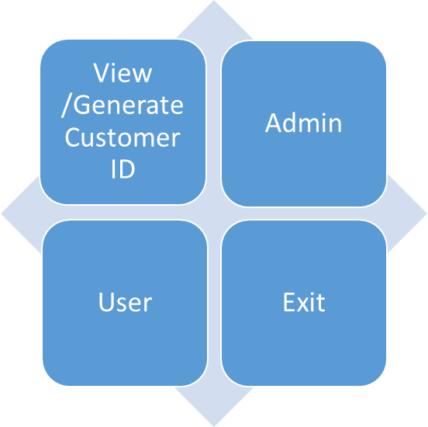
Fig: Homescreen

In view /generate customer id user can create there own customer ID from there basic data like name, citizenship no. etc so that they can be the part of several offers and prize like customer of the month.Only the admin can access the admin option as it is password protected and only the authorized person has the password, and the user doesn’t have any password. The user can buy the product from the bazar and bill is created as per the buying of user. The admin can access any portion and can see the profit or loss of the bazar. In exit portion one can terminate when it’s use is over. The user and admin can perform following things:

3.1 Customer ID
This portion mainly interact with with user. One can create or view customer ID.. also one can view their customer ID .
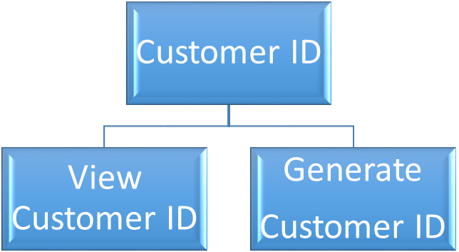

Fig :Customer ID

3.1.1 View Customer ID
There one can view the customer Id which has been already created. This conatin entire data related with customer which s/he had enterd while filling form for customer ID.

3.1.2 Generate customer id
In this portion user can create their customer id so that it will be benifital for future. In this program there is the facility of customer of the month and gift hampers so one can compite for that. In

3.2 Admin
Admin is the owner of the Sajha Bazar or one of the authorized person of the Bazar. Admin look after the bazar and makes the appropriate changes in it. To enter this portion password must be entered and only 3 chances are available to enter password other the admin is logged out. The works that s/he does is as shown in table below.
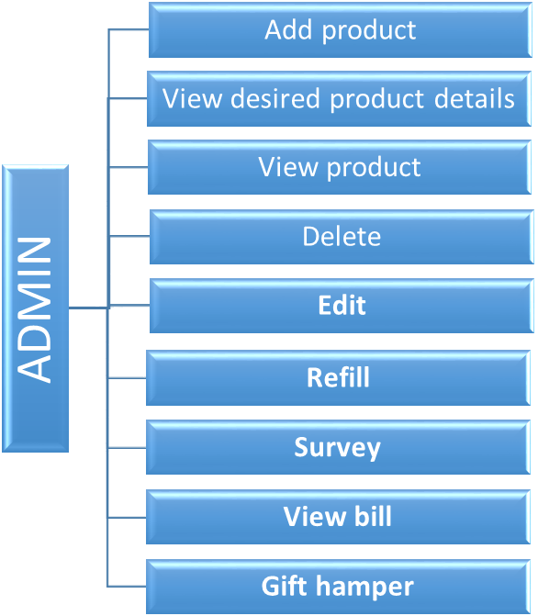

3.2.1 Add product
In this portion the admin adds the new products that s/he desires to sell. While adding the product dinfferent information such as name of product, id and selling price etc has to be written.
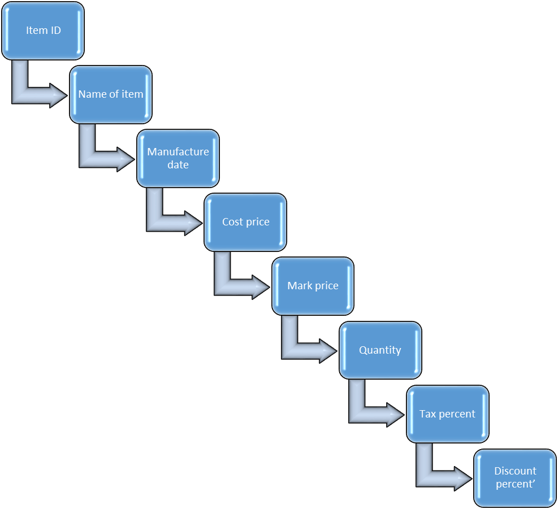
    - View desired product details
Sometime the admin may wish to know the information of specific products, in such cases this portion is useful. So in this portion admin after providing identification number of the product information about that product is displayed.
    - View product
In case admin desires to see all the products available, simply admin may use this option to view the general information of products.
    - Delete
While entering the product information if any mistake is done this portion can be invoked in order to delete that product.
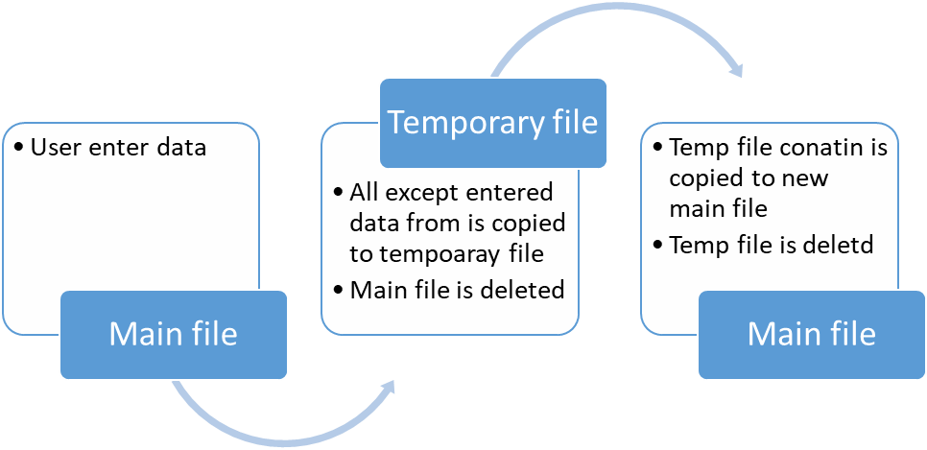

3.2.4 Edit
After the addition of new stock or after the end of year when new products are added their details ma also have been changed by the admin or government. In such cases this portion is call by admin to change the general information. It is also useful if the information provided while adding new product is wrong except product id and quantity.
    - Refill
If quantity of any product is less then required then admin need to add the quantity, to perform this task admin need to refill the product. In this portion only quantity can be added.
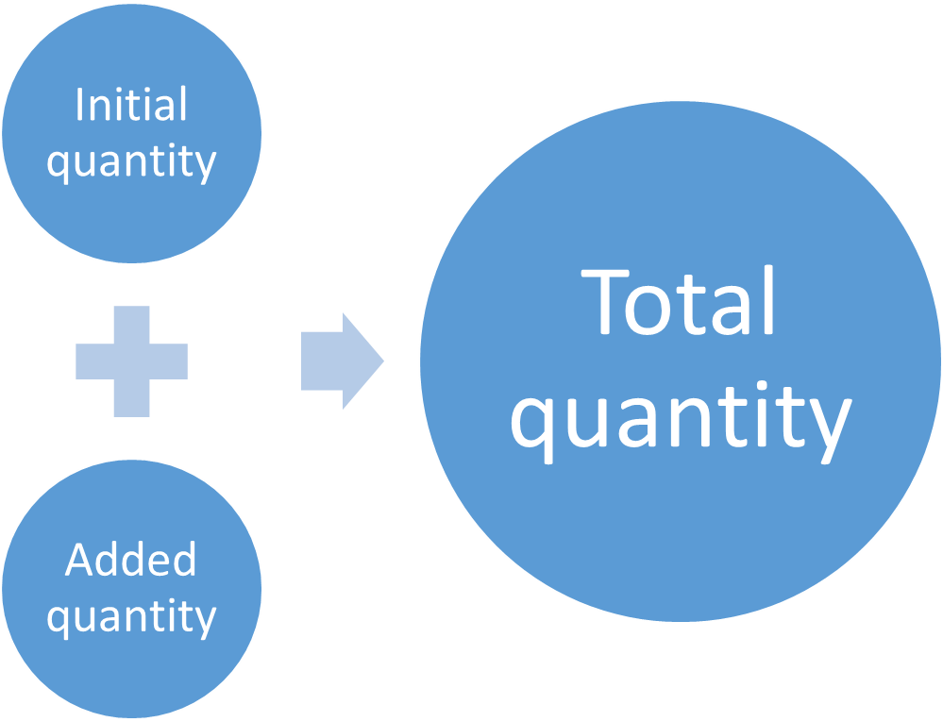

3.2.7 Survey the product
In any market its obeious that one day the stock gets over. So the market wont to provide the service to its costumer and their will be certain loss. To overcome this problem the admin can simply scan and if the stock of any product is below 10% then alert message will be displayed.
    - View bill
Admin can view the over all bill of the bazar using this portion.

    - Gift hamper
Based on the maximum buy of the costumer they are given different gifts, called gift hamper. After the end of certain interval the admin can run this part to find the user with maximum buy and that costumer is considered as best costumer and a hamper is given to the costumer. This feature is only for those costumer those who have costumer id

3.3 User
Simply a user is the consumer who buys the product from the Sajha bazar. The user can buy the desired items form the bazar and bill is made automatically and all the calculation is also perform automatically.things that can be seen in user mode are as follows.
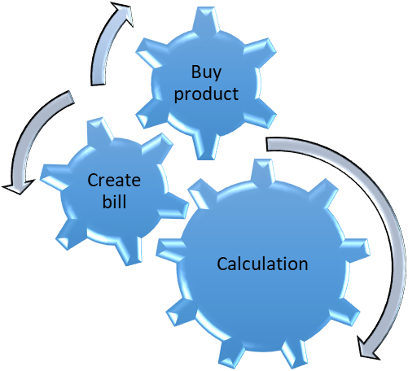
Fig: User procss

When any product is bought and if the costumer have costumer id, s/he can use it to get exciting prizes. But if costumer doesn’t have costumer id then also s\he can buy any thing but s\he cant get the opportunity to get exciting prizes. When any thing is bought every thing is calculated automatically.

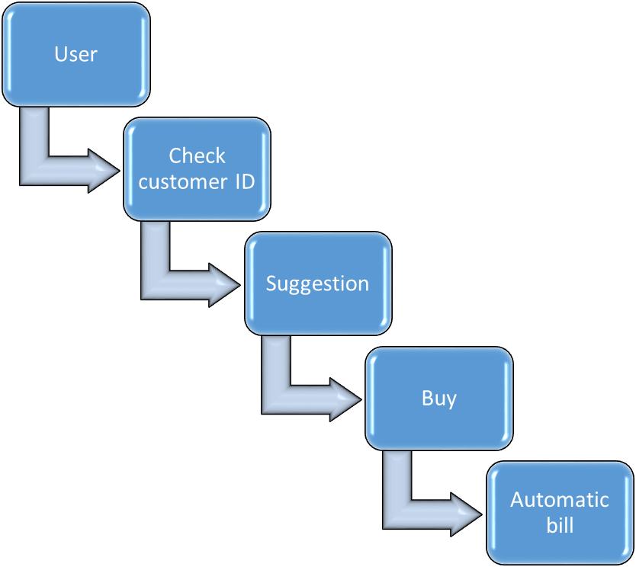

Fig:Userworking mechanism

Chapter 4: Implementation and Result

4.1 Implementation

4.1.1 Introduction
Implementation is the stage of the project when the theoretical design is turned out into a working system. Thus, it can be considered to be the most critical stage in achieving a successful new system and in giving the user, confidence that the new system will work and be effective. The implementation stage involves careful planning, investigation of the existing system and its constraints on implementation, designing of methods to achieve changeover and evaluation of changeover methods.
Some screenshots:
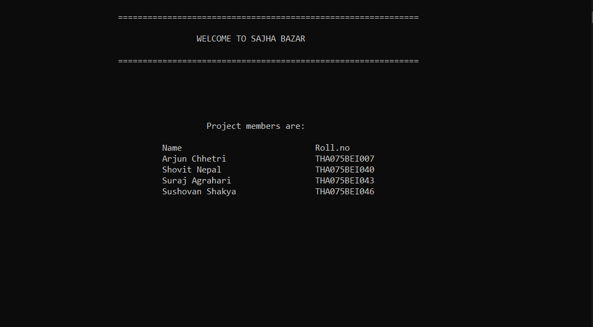
Welcome screen:

Home screen:

Home screen:
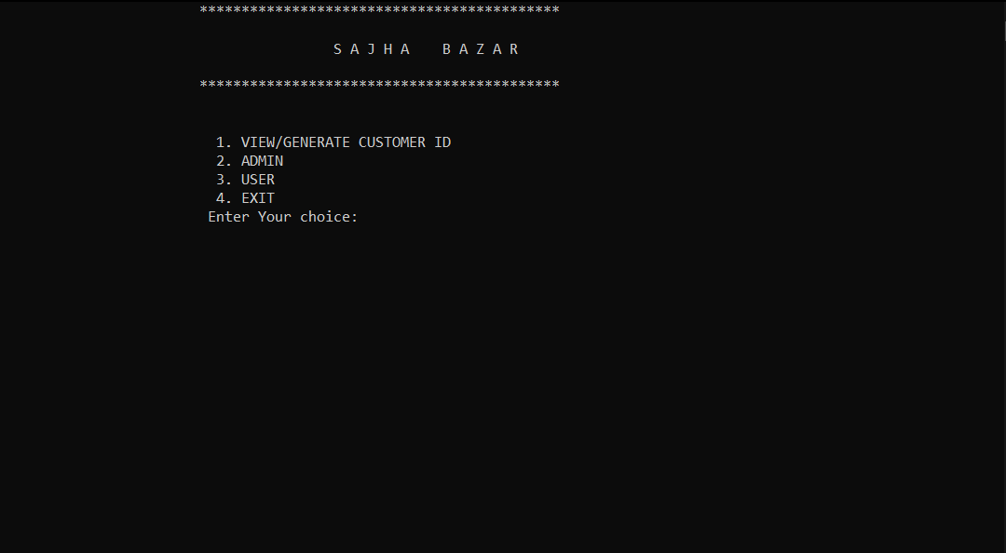

Admin :
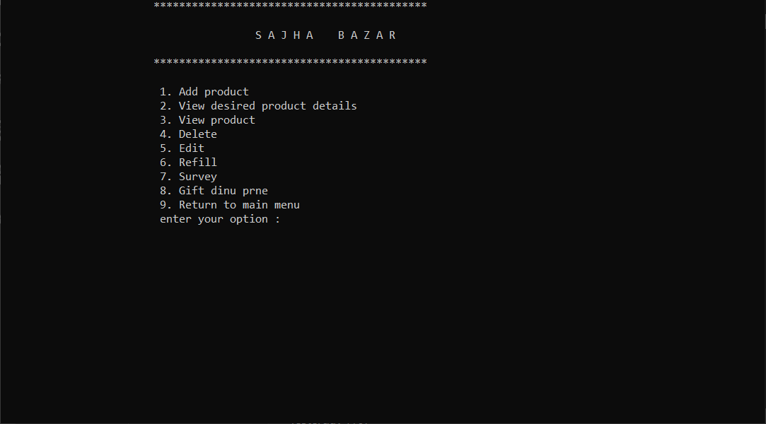

Add :
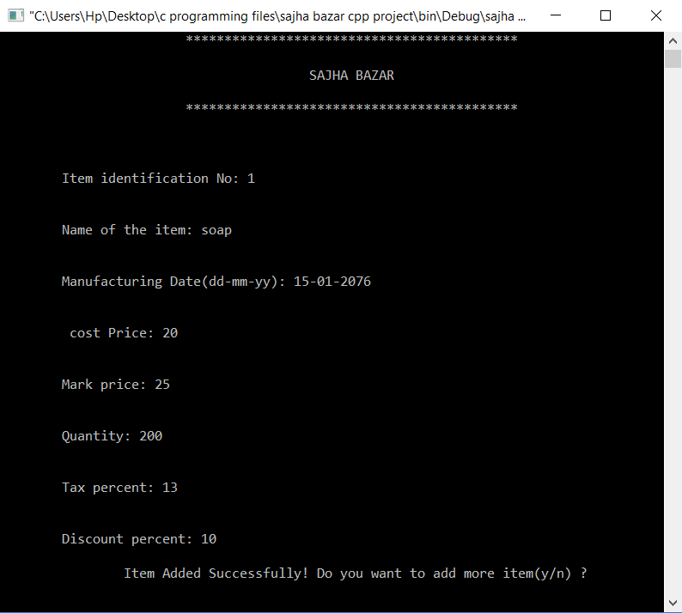
View individual detail
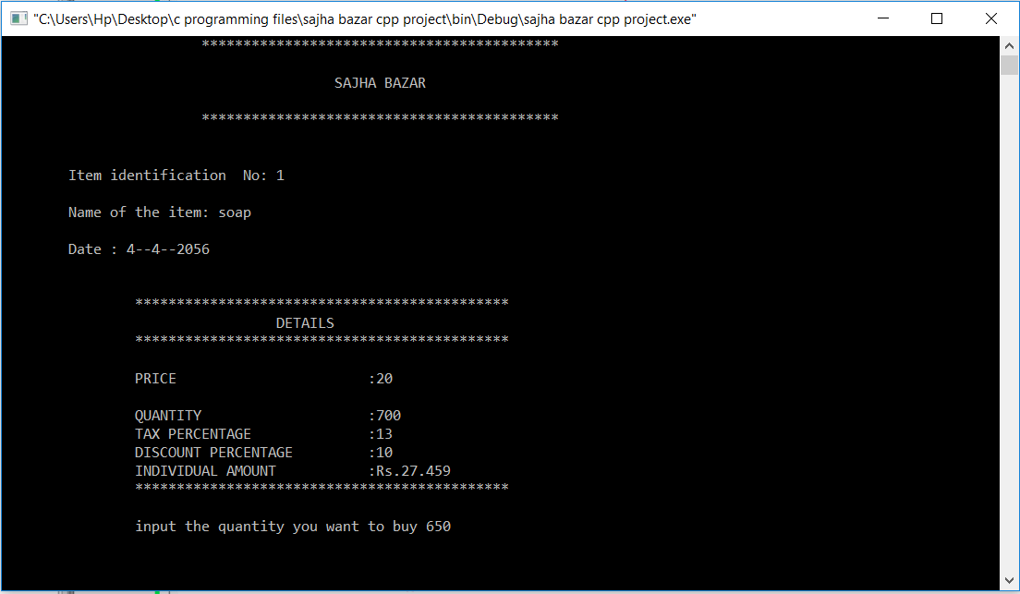

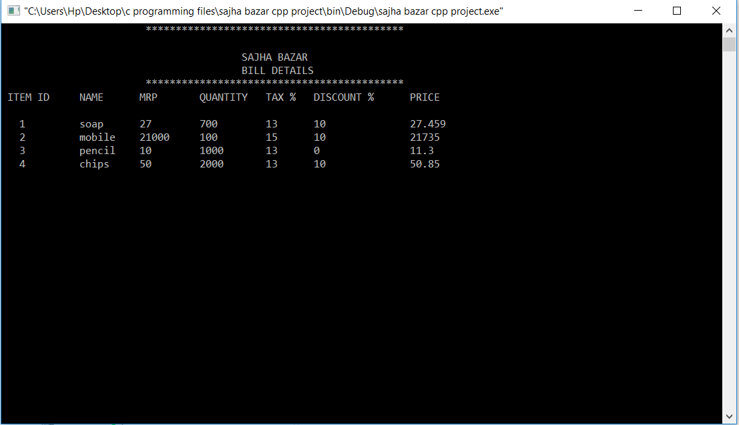
View all item detail

Delete
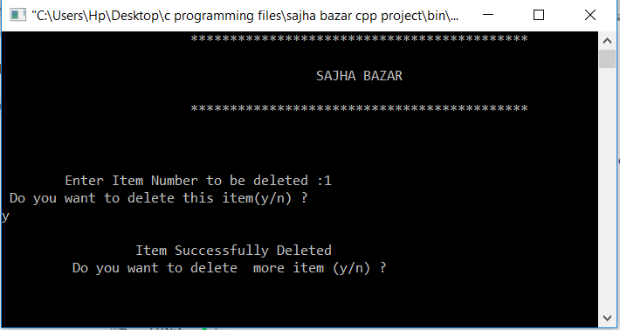
Edit
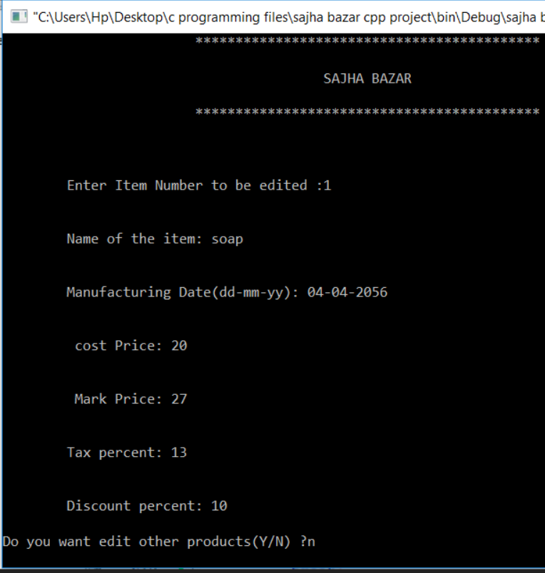
Refill
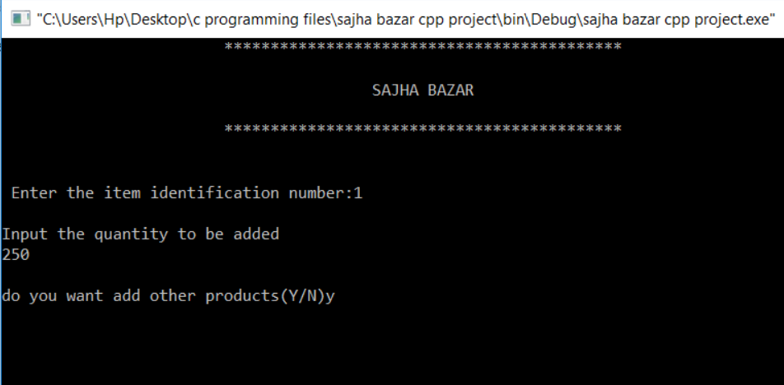
Survey
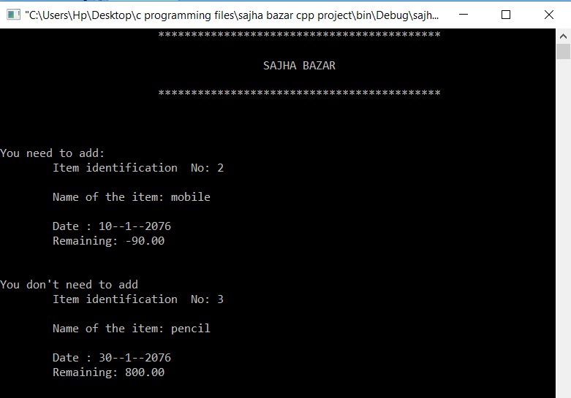
Gift hamper
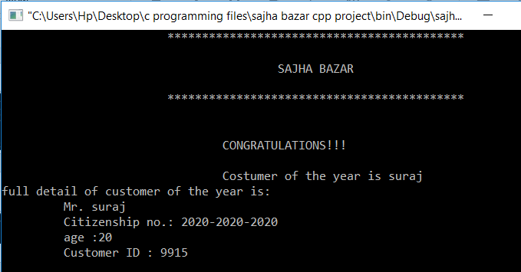
View customer id
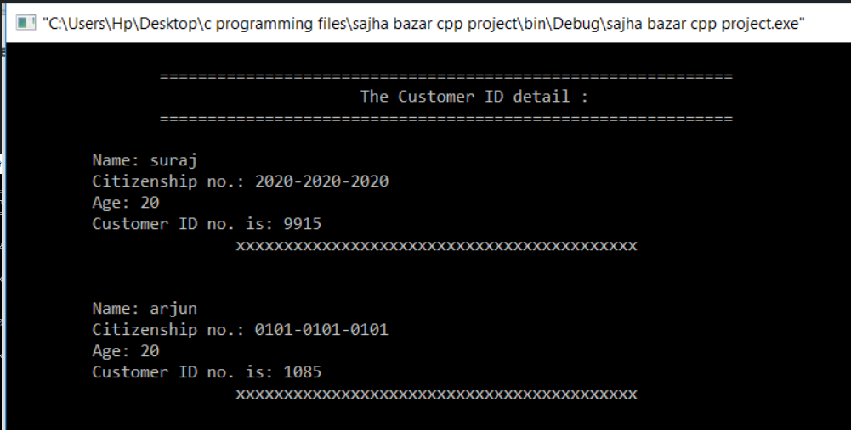
Generate customer ID
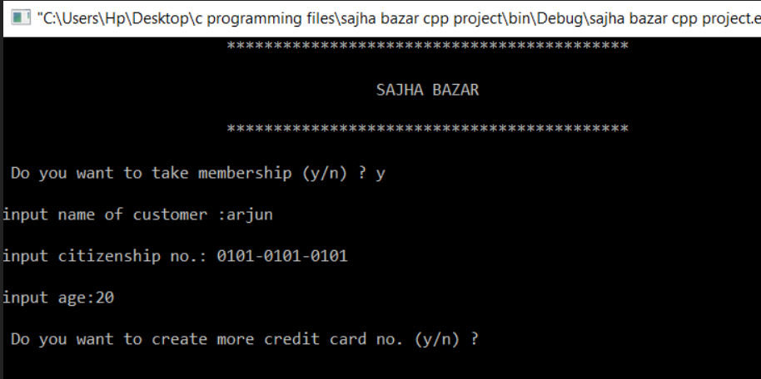
Suggest goods
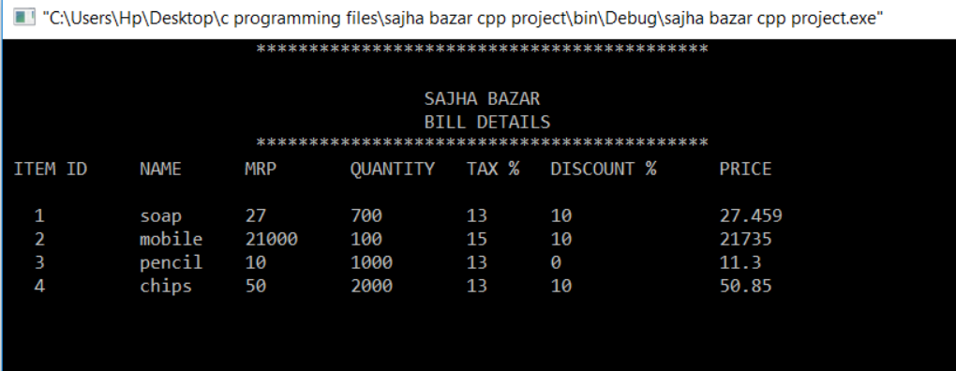
Buy
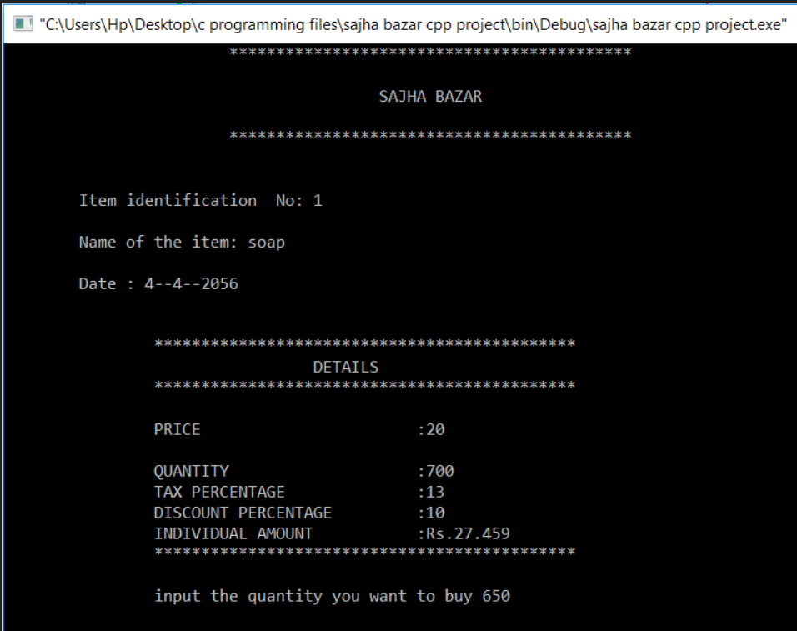
Bill
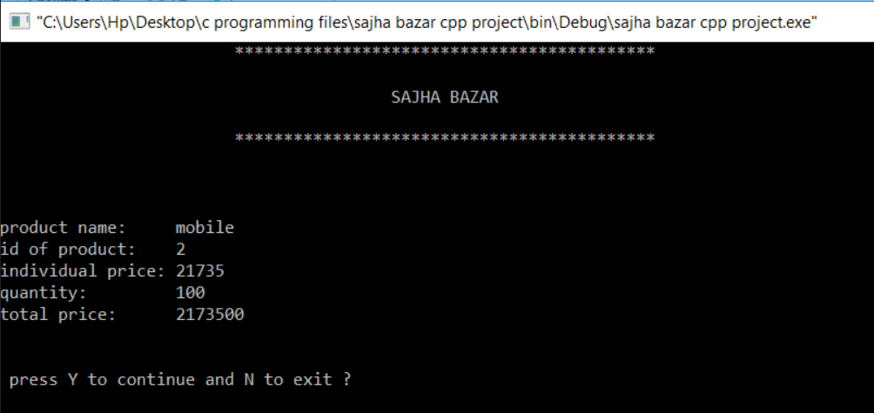

4.2 Result Analysis
The program runs in two different perspectives: administrator and user.
The admin has the permission to add, edit, refill, delete and view products and also conduct survey to obtain the data of the users of the application, that is, the customers. The survey feature of the application allows the admin to announce customer of the month and provide gift hampers to the regular customers of the store.
The user has the permission to view suggested items and check out, which proceeds to bill being generated, and eventually the item being purchased. Also, the applications enables the admin to generate unique customer ID which makes it easier to handle the regular customers of the store, and provide special services like discounts, offers, gift hampers, and also to handle the data for the calculation of profit and loss at the end of the fiscal year.

4.3 Limitations
File handling cannot control redundancy of data as each user defines and maintains the needed files for a specific application to run. There may be a possibility that two users are maintaining same files data for different applications. Hence changes made by one user does not reflect in files used by second users, which leads to inconsistency of data.
File handling can cause problems in file read/write. There are chances of file being overwritten or the file data being lost upon restarting the application. Thus, data loss is inevitable. Also, for every search operation performed on file system, a different application program has to be written. There might also be constrains, several of them, that needs to be applied on the data before being written on a file, which is why data entry in the file should be specified in the application every time it is being written.
The application is in command line form, which many end users may find difficult to use, and thus would prefer simple GUI-based applications, which would make things simpler and more efficient.

CHAPTER 5: CONCLUSION AND FURTHER WORKS

5.1 Conclusion
Thus, our application, “Sajha Bazaar”, was completed, which benefits the users in day-to-day buying/selling processes in stores. The use of this application will simplify the process, and will also enable the store of data in a more secure manner, hence allowing the store manager or owner to access the data for necessary calculations.

5.2 Further Works
Several of our works have been left incomplete due to lack of time and unexpected events. Future work concerns deeper analysis of particular mechanisms, new proposals to try various methods, or simply curiosity.
The application is in command line interface, and further works can be done to simplify the application for the end users through the use of different API and frameworks like GTK+ and Qt. Also, for the efficient handling and security of data, Database Management System (DBMS) can be implement through the use of SQL. The application can also be made open source for the ease of access for the users.

CHAPTER 6: Reference
- E Balagurusamy, “Object Oriented Programming With C++”, fourth edition
- Yashavant kanetkar , “ let us C” ,seventh edition
- AI Kelly and Ira pohl, “ A Book on C”, fourth edition
- http://www.wikipedia.org /wiki/literature review, 2019 jan 26
- http://www.ioe.edu.np
- Daya Sagar Baral, Duwakar Baral, Sharad Kumar Ghumire, “The Secrets of C Programming Language”

CHAPTER 7: APPENDICES
Core of the source code:
int main()
{
int ch;
float gtotal;
cout<<"\n \t\t\t=============================================================\n";
cout<<"\n\t\t\t\t\tWELCOME TO SAJHA BAZAR \n";
cout<<"\n \t\t\t=============================================================\n\n";
cout<<"\n\n\n\n\t\t\t\t\t Project members are:";
cout<<"\n\n\t\t\t\t Name\t\t\t\tRoll.no";
cout<<"\n\t\t\t\t Arjun Chhetri\t\t\ttha075bei007";
cout<<"\n\t\t\t\t Shovit Nepal\t\t\ttha075bei040";
cout<<"\n\t\t\t\t Suraj Agrahari\t\t\ttha075bei043";
cout<<"\n\t\t\t\t Sushovan Shakya\t\ttha075bei046";
getch();
while(1)
{
menu:
std::string password,again;
static int tryd=3;
design(45,'*');
cout<<"\n\t\t\t 1. VIEW/GENERATE CUSTOMER ID ";
cout<<"\n\t\t\t 2. ADMIN ";
cout<<"\n\t\t\t 3. USER ";
cout<<"\n\t\t\t 4. EXIT ";
cout<<"\n\t\t\t Enter Your choice: ";
cin>>ch;
switch(ch)
{
case 1:
craditcard();
break;
case 2:
if(tryd>=1)
{
done: cout <<"\n\n\n\t\t\t\tEnter the password for Admin : ";
password = getpass("Please enter the password: ", true);

if(password=="admin")
{
admin();
getch();
break;
}
else
{
tryd--;
design(50,'*');
if(tryd>=1)
{
cout<<"\n\n\n\t\t\tWrong password you have "<<tryd<<" chances left:";
cout<<"\n\n\n\t\t\t Do you want to try again (y/n) ? ";
cin>>again;
if(again=="y"||again=="Y")
goto done;
}
break;
}
}
else
cout<<"\n\n\n\t\t\t Password try limit exceeded.";
getch();
break;
case 3:
user();
break;
case 4:
design(45,'*');
gotoxy(20,15);
cout<<"ARE YOU SURE, YOU WANT TO EXIT (Y/N)?";
char yn;
cin>>yn;
if((yn=='Y')||(yn=='y'))
{
design(45,'*');
gotoxy(20,15);
cout <<"|=======================================================================|";
gotoxy(20,16);
cout<<"|********************************THANKS*********************************|";
gotoxy(20,17);
cout <<"|=======================================================================|";
getch();
exit(0);
}
else if((yn=='N')||(yn=='n'))
goto menu;
else
{
goto menu;
}
break;
default:
cout<<"\n\n\n\n\t\t\t\t\tEnter valid choice\n";
getch();
break;
}
}
return 0;
}

For complete code please visit:
Tha075bei043@tcioe.edu.np

